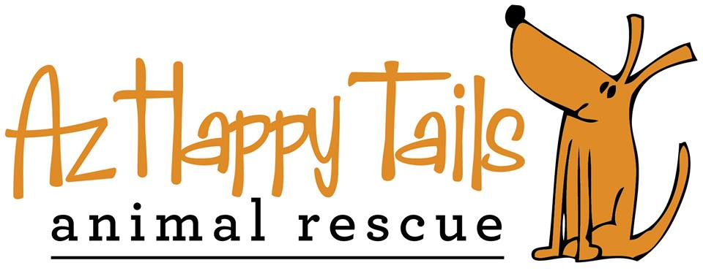

FOSTER CARE APPLICATION & AGREEMENT
A HOME VISIT IS REQUIRED PRIOR TO THE PLACEMENT OF AN ANIMAL

FAMILY AND HOME INFORMATION

Primary Name: _____________________________________________________
Address: _________________________________________________________________________________

City: __________________________________________ State: ____________ Zip: ___________

Is this address: Permanent Seasonal: If seasonal when are you in AZ? _______________________

Do you: Own Rent: If rent, please provide copy of lease that states you may have animals

Do you have an HOA? Y or N If so, what is the limit of how many animals you may have: _________

Phone Numbers:

Home: ________________________ Cell: ________________________ Work: ____________________

Email Address: ____________________________________________________________________________

Do you have an outdoor enclosed area?: ____________________ How high is the barrier?: ______________

Do you have a doggie door?:________ Do you have a swimming pool/spa: ________ Is it fenced?: _______

Please provide the name and age of other household members not listed above:

Name

Please list any animals you presently have in your home:

Species/Breed | Length of time in home | Neutered/Spayed? | Vaccinated/Licensed? | In/Outdoor pet? | Where did you get the pet?

Have you ever surrendered a pet? If so, please explain: ______________________________________________________________________________________________________________________________________________________________________________________________________________________________________________________________________________________

Please circle any diseases your household pets may have had: Parvo, Distemper, Feline Leukemia, FIV

Other: ________________________________________________ When: ____________________________

What do you prefer to care for (please check all that apply):

Small Adult Dogs Puppies Nursing Mom with Puppies

Medium Adult Dogs Large Adult Dogs

What ages (please check all that apply):

Under 1 Year 1-3 Years 3-6 Years
Over 6 Years No Preference

Are you willing to foster an animal that needs training: Yes No

Are you willing to foster an animal with medical issues: Yes No

Are you willing to foster an animal that requires medication: Yes No If yes, please detail your prior experience with administering medications: _________________________________________________________________________________________

_________________________________________________________________________________________

Would you foster multiple pets?___________ If so, how many?:____________________________________

Where will your foster animals be housed?: _______________________________________________________

Will your foster animals be housed separately from owned animals?: _________________________________

How many hours a day will your foster animal be left alone?: ________________________________________

What enrichment activities will the foster animal receive?:

_________________________________________________________________________________________

_________________________________________________________________________________________

Are you willing to foster an animal or litter until it/they are adopted:____________________________

TERMS OF FOSTERING FOR AZ HAPPY TAILS

I agree that my services as a Foster Care Provider are provided on a strictly volunteer basis. I shall receive no pay, benefits, or compensation of any kind from AZ Happy Tails Animal Rescue for my foster care of animals.

I agree to provide foster care in strict compliance with the policies and procedures of AZ Happy Tails Animal Rescue. This includes, but is not limited to:

- Providing adequate food, water, shelter, safe containment, and humane treatment for the animal(s) at all times.
- Providing medication and veterinary care when needed at the expense of AZ Happy Tails Animal Rescue and with their approval beforehand.
- Monitoring the animal(s) and providing proper care and socialization.
- Notifying AZ Happy Tails Animal Rescue immediately of any major change in the foster animal’s health.
- Immediately notifying AZ Happy Tails Animal Rescue if an animal becomes lost.
- Attendance of animals at adoptions events.
- Allow a transporter to take animals to adoption events if you are unable.
- Representing yourself in a professional manner to members of the community and representatives and volunteers of AZ Happy Tails.

Please write your initials on the line to the left of each paragraph after you have read it.

_____ AZ Happy Tails Animal Rescue reserves the exclusive right to determine the proper course of action to take upon notification by the foster parent of any inability to comply with this agreement.

_____I understand and agree that the fostered animal(s) are the exclusive property of AZ Happy Tails Animal Rescue. This agreement transfers no ownership rights.

_____I understand that all foster animal(s) must be scheduled for needed medical treatment (altering, vaccinations, microchip, testing, etc) at one of the AZ Happy Tails Animal Rescue approved veterinarians.

_____I will respect AZ Happy Tails Animal Rescue’s decision to determine whether a foster parent can adopt a foster animal.

_____I understand that I must comply with the following adoption protocol:

- AZ Happy Tails Animal Rescue requires Adoption Application review and approval by a Director of AZHT or a designated appointee prior to any scheduled home visit.
- AZ Happy Tails Animal Rescue requires a home visit by a Director of AZHT or a designated appointee prior to the finalization of any adoption.
- In no case will an animal be allowed to leave an adoption event with a prospective adopter without approval by a Director of AZHT.
- AZ Happy Tails Animal Rescue requires that any AZHT animal that needs to be rehomed for any reason at any time after adoption MUST be returned to AZ Happy Tails Animal Rescue.

_____I will agree to vaccinate my own animals against the following diseases before fostering:

- Canines are immunized against Canine Distemper, Canine Parvovirus, Parainfluenza, Hepatitis (4 in 1 booster); Bordetella (kennel cough); Rabies; and are free of parasites.
- Felines are immunized against Feline Panleukopenia, Rhinotracheitis, Calicivirus (3 in 1 booster); and are free of parasites.

_____If I choose to not vaccinate my animals, I understand that AZ Happy Tails Animal Rescue will not be responsible for any illness that occurs related to non-vaccinated animals.

_____I understand that foster animals may carry contagious disease that could affect owned animals or humans. I understand that AZ Happy Tails Animal Rescue will not be responsible for any expenditures resulting from this.

_____I understand no reimbursement by AZ Happy Tails Animal Rescue will be given to me regarding any expenditure, which I incur for the care and treatment of the foster animal(s) that was not approved in advance.

_____I understand if a foster animal under my care or my own animal dies from a contagious disease, I will not be considered for fostering other animals of the same species for a specific length of time as deemed suitable by AZ Happy Tails Animal Rescue. Discussion with an AZ Happy Tails Animal Rescue approved veterinarian will determine the length of time necessary before fostering any animal again in the foster provider’s home.

_____I understand that I may not rescue or New Hope an animal without prior approval from AZ Happy Tails Animal Rescue.

_____I understand that any breach of the conditions of this foster care agreement may result in immediate termination of this agreement. In that case, AZ Happy Tails Animal Rescue shall take immediate possession of the fostered animal(s).

INDEMNITY

_____I agree to release, discharge, indemnify and hold harmless AZ Happy Tails Animal Rescue, including its agents and employees, for any personal injuries or damages to property or pets caused by the foster animal(s).

_____I recognize that in handling foster animal(s) there exists a risk of injury including physical harm caused by a foster animal. On behalf of myself, my heirs, personal representatives and executors, I release, discharge, indemnify and hold harmless AZ Happy Tails Animal Rescue, its agents, volunteers, and employees from any and all claims, causes of action or demands, or ay nature of cause connected with my foster care agreement.

I have received, read and understand the Foster Care Guidelines provided by AZ Happy Tails Animal Rescue.

________________________________________________________ ____________________________
Foster Care Provider Signature Date

_______________________________________________________ ____________________________
AZ Happy Tails Animal Rescue Representative Signature Date

Completed applications can be sent to: inquiries@happytailsaz.org

